**Assessment Question**

**Task 3: JavaScript Programming Basics**

1. **Explain the difference between var, let, and const. Provide examples.**

**Answer:** In JavaScript, var, let, and const are used to declare variables, but they have different behaviors regarding scope, hoisting, and reassignment.

1. **Var**

* **Scope**: Function-scoped. This means var is limited to the function in which it is declared. If declared outside any function, it becomes global.
* **Hoisting**: Variables declared with var are hoisted, meaning they are moved to the top of their scope during the compilation phase. However, their initialization remains where the actual code is, and before the initialization, they are undefined.
* **Reassignment**: You can reassign and redeclare variables declared with var.

**Code:**

function varExample() {

    console.log(x);

    var x = 10;

    console.log(x);

  }

  varExample();

**Output:**

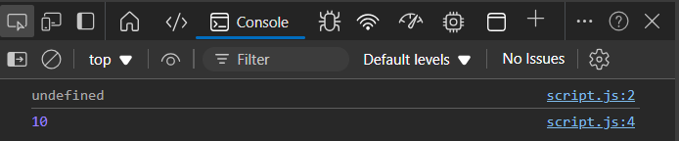

1. **Let**

* **Scope:** Block-scoped. This means let is confined to the nearest enclosing block (denoted by {}), such as loops, conditionals, or functions.
* **Hoisting:** Variables declared with let are hoisted but not initialized. Accessing them before declaration results in a ReferenceError.
* **Reassignment**: You can reassign variables declared with let, but they cannot be redeclared in the same scope.

**Code:**

function letExample() {

  let y = 20;

  console.log(y);

}

letExample();

**Output:**

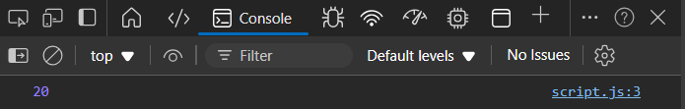

1. **const**

* **Scope:** Block-scoped, like let.
* **Hoisting:** Variables declared with const are hoisted but not initialized, similar to let. Accessing them before declaration results in a ReferenceError.
* **Reassignment**: You cannot reassign or redeclare const variables. They are **immutable** references, meaning the reference to the value is constant, though if the value is an object or array, its contents can be changed.

**Code:**

const z = 30;

console.log(z);

// z = 40; if we add z=40; then it will return type error

const arr = [1, 2, 3];

arr.push(4);

console.log(arr);

**Output:**

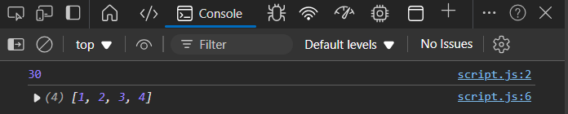

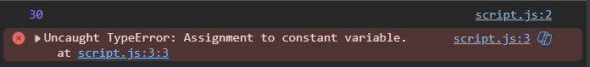

1. **Write a for loop to print all even numbers between 1 and 10.**

**Answer:**

**Code:**

for (let i = 2; i <= 10; i += 2) {

    console.log(i);

  }

**Output:**

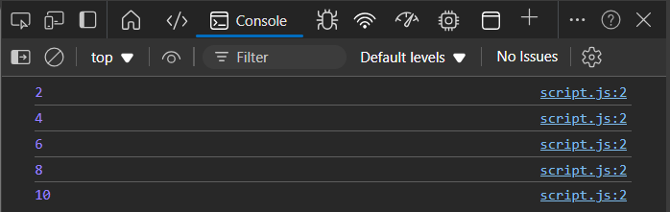

1. **Write a while loop that keeps doubling a number (starting from 1) until it is greater than or equal to 100.**

**Answer:**

**Code:**

let num = 1;

while (num < 100) {

  console.log(num);

  num *= 2;

}

**Output:**

